Task 1:

#include <LiquidCrystal.h>

LiquidCrystal lcd(13, 12, 11, 10, 9,8 );

void setup()

{

lcd.begin(16, 2);

}

void loop()

{

float voltage = analogRead(A0);

voltage = ((voltage\*5)/1023);

lcd.setCursor(0, 0);

lcd.print("analog val = " );

lcd.setCursor(12, 0);

lcd.print(voltage);

delay(200);

}

Output:

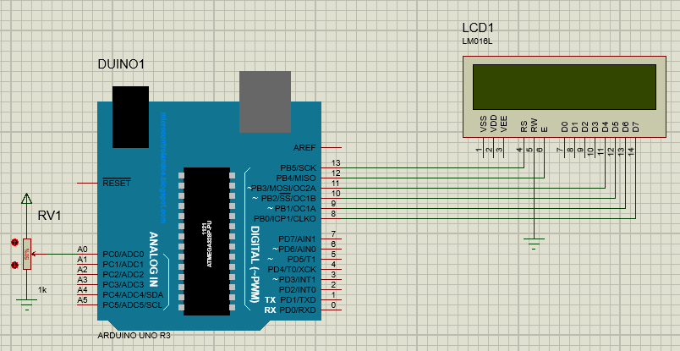

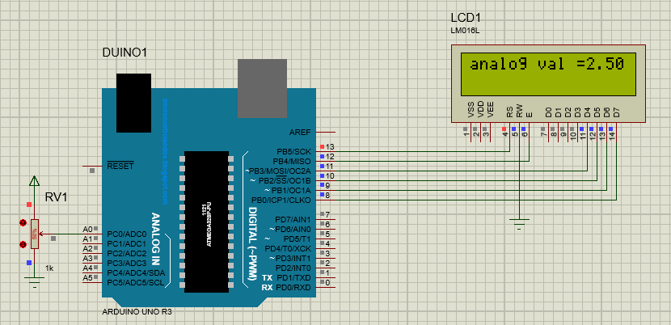

Task 2:

int tempPin=A0;

float temp;

#include <LiquidCrystal.h>

LiquidCrystal lcd(12, 11, 5, 4, 3, 2);

void setup()

{

lcd.begin (16, 2);

lcd.print("Temperature=");

// Activating both Rows of LCD.

}

void loop()

{

temp = analogRead (tempPin);

temp = temp\*0.48828125;

// Reading the Temperature.

// Conversion Factor.

delay (1000);

lcd.setCursor (0, 1);

lcd.print(temp);

lcd.print(" Centigrade");

}

Output:

